**P.7 Mathematics**

1. Multiply 32 x 4
2. Simplify -7 - -4
3. Find the value of 30 tens and 2 ones
4. A dozen books was bought by a business man at sh. 6000 and he sold each book at sh. 650. Calculate the profit he got after selling all the books.
5. Solve for x: x -4 = 3(mod 5)
6. A forty-five minute lesson started at 12:30p.m. At what time did it end in the 24 hour clock system?
7. Study the diagram below

P

Q

N

N

160

Find the bearing of P from Q

1. Find the next numbers in the sequence below

5, 13, 25, 41, 61, _____, _____

1. A spinner is made from a regular pentagon and labeled 1- 5

What is the probability of a score of a prime number appearing?

1. Express $\frac{2}{3}$ to $\frac{5}{6}$ as a simplified ratio
2. Paul had a bundle of 100 notes numbered consecutively from AP845201. Find the serial number of the last note in the bundle
3. Find the value of K in degrees in the figure below

350

2k

3k

1. Factorize 9t + 3t2 completely
2. Moses had $\frac{1}{2}$ a bar of soap, he gave $\frac{1}{4}$ of it to Sarah. What fraction of the soap did he remain with?
3. Using a pair of compasses, sharp pencil and ruler only, construct an angle of 1650
4. In an examination, 55% of the pupils scored above 70%, if 54 pupils scored below 70%. Find the number of pupils who scored above 70%
5. Solve for g:

10g3 – 4 = 76

1. The diagram below shows a net of a triangular Prism with two faces missing, complete the net by drawing the two missing faces.
2. A workers daily wage was increased from sh. 24,000 to sh. 28,000. In what ratio was the workers wage increased?
3. The prism factors of P and Q are represented in the diagram below, use it to answer the questions that follow

Given that the highest common division (HCD) of P and Q is 30, find the value of P.

Fp

Fq

32

22

31  51

m

**SECTION B**

1. Workout 3 1 2five (2mks)

-1 2 3five

b) Express CXCVI in words (2mks)

1. A taxi driver left Kampala for Masaka with 14 passengers. Each passenger paid sh. 13,000, the total collection the conductor bought 9 litres of petrol at sh. 5200 per litre.
2. How much money did the conductor collect from the passengers? (2mks)
3. How much money did the conductor remain with after paying for the fuel? (3mks)
4. Study the figure below and answer the questions that follow

The area of the semi-circle is 308dm2. Find the area of the shaded part

(5mks)

1. Using a pair of compasses, pencil and ruler only, construct a rhombus PQRS such that SRQ=1200 and SR=6.5cm. (4mks)

b) Measure diagonal PR. (1mk)

1. In a party, two types of food was served, chicken(C) and fish(F) 28 guests ate chicken and k guests ate both Fish and Chicken, 4 guests ate neither of the foods, while 14 guests ate only fish. The number of guests who ate chicken only was thrice that of those who ate both chicken and fish.
2. Use the information given to complete the Venn diagram. (2mks)

n(F)=____

n(C)=28

14 k _____ _____

4

1. Find the number of guests who ate both fish and chicken. (2mks)
2. Find the total number of guests who attended the party (1mk)
3. The mean age of 6 boys is 12 years, when two other boys join the group the mean age becomes 13 years. The seventh boy is 6 years older than the eighth boy.

Find the age of the seventh boy (5mks)

1. A rectangular sheet is curved into a cylindrical tin whose height is 30cm as shown below.

66cm

30cm

1. Find the diameter of the tin (2mks)
2. Calculate the area of the sheet needed to cover the base of cylindrical tin (3mks)
3. A motorist travelling at 100km/h takes 3 hours 36 minutes to travel from town A to town B
4. Find the distance from town B to town A (2mks)
5. If the motorist starts his return journey from town B at 2:00p.m, at what speed must he drive without stopping in order to arrive town A at 6:00p.m? (3mks)
6. Study the figure below, and find the value of x (2mks)

2x

360

880

b) The sum of the interior angles of a regular polygon totals to 12 right angles. Find the size of each exterior angle of the polygon (3mks)

1. The distance from Tororo town to Mbale town is 45km on the map of Uganda the distance between the towns is 5cm. Find the scale on the map (2mks)

b) The scale on a map is 1:20,000, find the actual distance in km if the distance is 6.5cm. (3mks)

1. Mama Paul went shopping and bought the following;

* 3kgs of maize flour at sh. 3400 per kg.
* 750gms of groundnut paste at sh. 3200 per kg
* 12 oranges at sh. 1400 for every 3 oranges

If Mama Paul received a change of sh. 1800, find the amount of money she had at the beginning (5 mks)

1. A motorist left town P at 7:30 am driving at an average speed of 40km/hr for 3 hours to town Q. He stopped at Q for a half an hour and then left for town R covering 160km in 2 $\frac{1}{2}$ hours.
2. 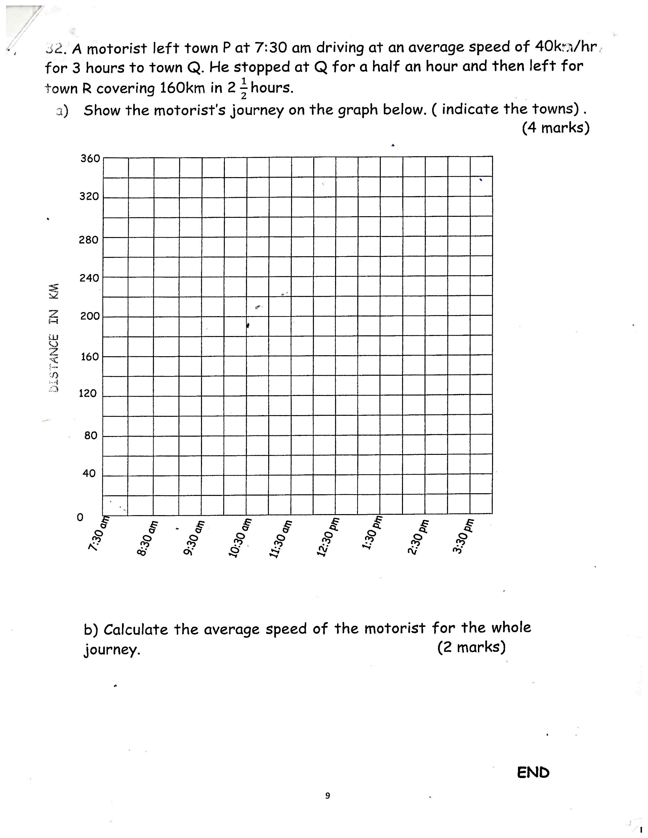Show the motorist’s journey on the graph below.(indicate the towns) (4mks)
3. Calculate the average speed of the motorist for the whole journey. (2mks)